7.15.10.22 E-shop orders check / chemical products

We are checking availabilty of our products via this function.

Order: place sales order number
To: place the same order number
+ Next
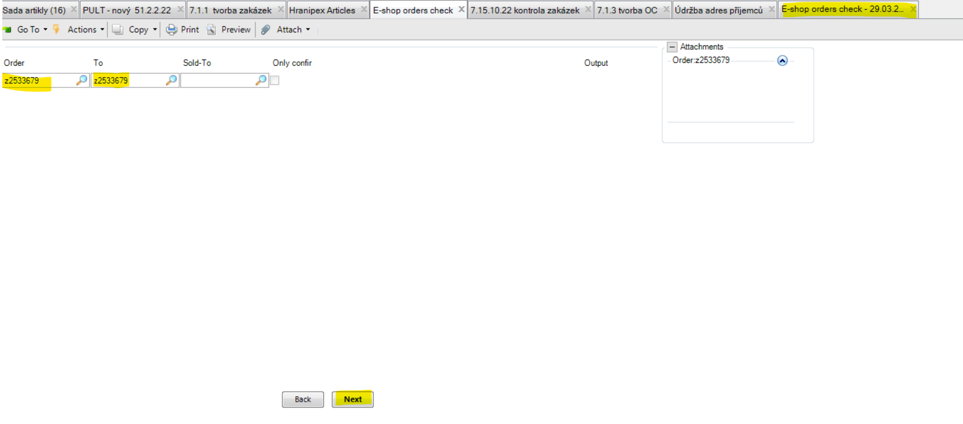

Below report shows us that we miss or do not have enough of 883HRX01XXX0001 (01 manual cleaner # 1l).
If there is no line in the report, it means that all is in stock.

Stk.(200) = means how many Qties has HRX HQ in stock
Ord.(200) = means how many Qties has HRX HQ on sales orders
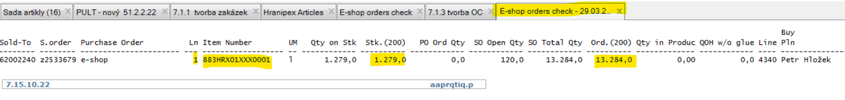

I usually copy all products from this report (one by one) and go directly to Hranipex Articles function to check the availability in more details. Just to be sure. From my point of view this above report can be a bit confusing.
But t is important to use this function to know if there is some line which needs to be checked.
To check availability of chemical products can be a bit more complicated in comparison with the edges.
This article is Hraniclean and in package of 1l it is ADR limited quatity (so called LQ article).
Means this is just a very small amount of ADR goods. Can be send also as 1 colli via DHL Economy.
The internet says: LQ refers to small receptacles (typically of the sort that go into the retail distribution chain) which are packed in boxes or on shrink-wrapped trays
As you can see below, there is big Qties on our sales orders.
By using function 13.6 Product Structure Inquiry you check from what components is this article produced in HRX production (it is 883HRX01XXX0001E).
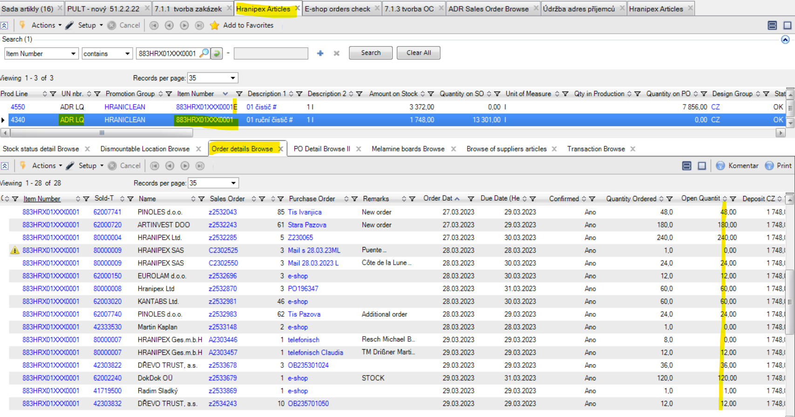

According to proper information about sub-articles you can easily check if we can produce and when.

